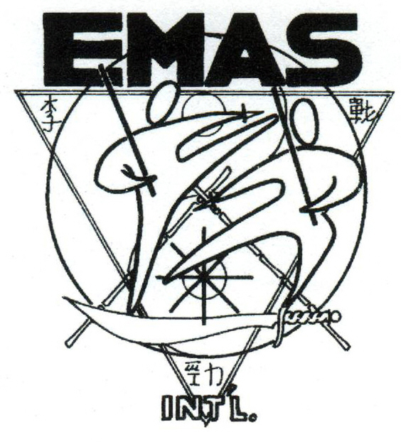
Join Our Martial Arts Family
Martial Arts Training by Highly Qualified Martial Arts Instructors…

Come and train with us, where your personal proclivities, individual strengths, and limitations, are all taken into consideration to customize a full spectrum of self defense skills… perfectly suited to you and your needs.
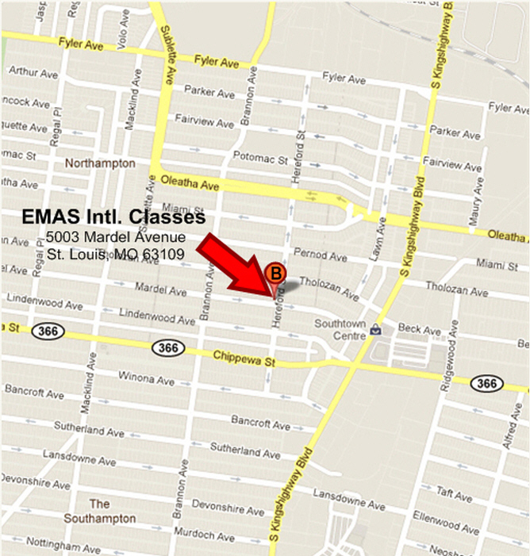
Why Train with EMAS International?
- Certified Professional Black Belts
- 35+ Years Of Martial Experience
- Practicality Heavily Emphasized
- Intimate Class Sizes (10 person max)
- Women’s Self Defense Classes
- Weapons Awareness and Training
- International Student Body
- EMAS.com Tutorial Website
sijogregorytaylor@gmail.com
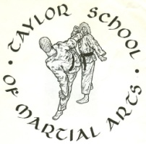
Lee Tzun Gin Sijo Gregory L. Taylor
Tai Ji Quan Sifu Joshua K. Eaves

