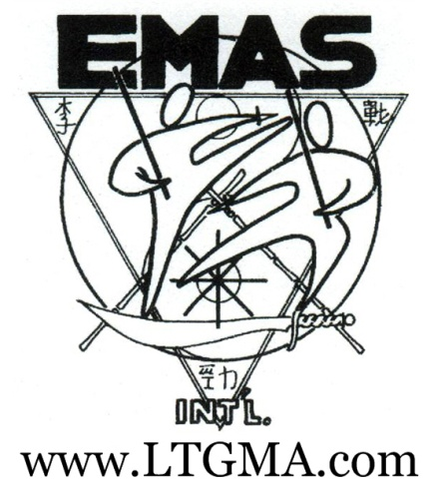
Martial Arts Classes
- Free Online Training and Resources
- Specialized / Invitational Group Classes
- Individual Adaptive Training Strategies
- Self Preservation and Confidence
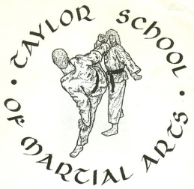
- Practicality and Effectiveness Emphasis
Senior Staff: Sijo Gregory L. Taylor  Sifu Joshua K. Eaves
Arts and Offerings
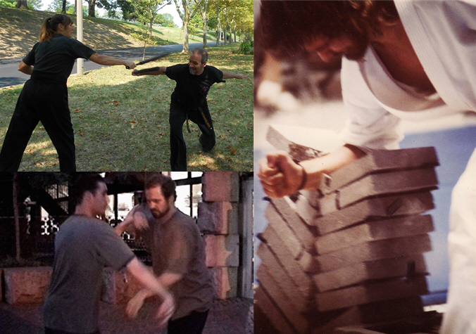
- Lee Tzun Gin
- Tae Kwon Do
- Judo / Ju Jitsu
- Kali / Silat
- Aiki Jutsu
- Taichi Chuan
- Xingyi Chuan
- Bagua Zhang
www.LTGMA.com  Sijo Gregory Taylor  (314) 276-3604  Leave message | www.LTGMA.com  Sijo Gregory Taylor  (314) 276-3604  Leave message | www.LTGMA.com  Sijo Gregory Taylor  (314) 276-3604  Leave message | www.LTGMA.com  Sijo Gregory Taylor  (314) 276-3604  Leave message | www.LTGMA.com  Sijo Gregory Taylor  (314) 276-3604  Leave message | www.LTGMA.com  Sijo Gregory Taylor  (314) 276-3604  Leave message | www.LTGMA.com  Sijo Gregory Taylor  (314) 276-3604  Leave message | www.LTGMA.com  Sijo Gregory Taylor  (314) 276-3604  Leave message | www.LTGMA.com  Sijo Gregory Taylor  (314) 276-3604  Leave message | www.LTGMA.com  Sijo Gregory Taylor  (314) 276-3604  Leave message
We also offer special classes for the LGBT Community

